**Time Measurement**

cTimeInMs = (uint32_t) (DWT->CYCCNT) / (uint32_t) (240000);

.

.

.

Code

.

.

.

lTimeInMs = (uint32_t) (DWT->CYCCNT) / (uint32_t) (240000);

TimeChangeInMs = (lTimeInMs - cTimeInMs) * 1;

**Results**

Display Thread

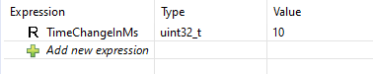

Input Capture Thread

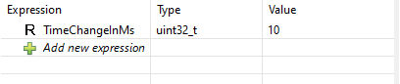

ADC Thread

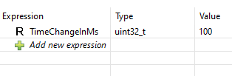

Main Control Thread

